|  |  |
| --- | --- |
| **VISVESVARAYA TECHNOLOGICAL UNIVERSITY**  **“JnanaSangama”, Belgaum -590014, Karnataka.**        **DATA STRUCTURE LAB RECORD**      ***Submitted by***    **SHASHWAT KHANNA (1BM19CS148)**    ***Under the Guidance of***    **Prof. LOHITH JJ**  **Assistant Professor, BMSCE**  ***in partial fulfillment for the award of the degree of***  **BACHELOR OF ENGINEERING**  ***in***  **COMPUTER SCIENCE AND ENGINEERING**        **B.M.S. COLLEGE OF ENGINEERING**  **(Autonomous Institution under VTU)**  **BENGALURU-560019**  **Sep-2020 to Jan-2021** | 1 |

**B. M. S. College of Engineering,**

**Bull Temple Road, Bangalore 560019**

**(Affiliated To Visvesvaraya Technological University, Belgaum)**

# Department of Computer Science and Engineering



## CERTIFICATE

This is to certify that the **LAB RECORD** is carried out by **SHASHWAT KHANNA (1BM19CS148)** who is a bonafide student of **B. M. S. College of Engineering.** It is in partial fulfillment for the award of **Bachelor of Engineering in Computer Science and Engineering** of the Visveswaraiah Technological University, Belgaum during the year 2020-2021. The lab report has been approved as it satisfies the academic requirements in respect of **DATA STRUCTURE LAB RECORD (19CS3PCDST)** work prescribed for the said degree.

Signature of the Guide Signature of the HOD

Prof. Lohith JJ Dr. Umadevi V

Assistant Professor Associate Prof.& Head, Dept. of CSE

BMSCE, Bengaluru BMSCE, Bengaluru

External Viva

Name of the Examiner Signature with date

1._____________________________ ________________________

2. _____________________________ _________________________

**LAB PROGRAM 1**

**Write a program to simulate the working of stack using an array with the following :**

1. **Push**
2. **Pop**
3. **Display**

**The program should print appropriate message for stack overflow and stack empty.**

#include<stdio.h>

#include<process.h>

#include<conio.h> #define STACK_SIZE 5

int top=-1; int s[10]; int item; void push()

{

if(top == STACK_SIZE - 1)

{

printf("Stack Overflow \n"); return;

}

top = top +1; s[top] = item;

} int pop()

{ if(top == - 1) return - 1;

return s[top--];

} void display()

{

int i; if(top == - 1)

{

printf("Stack is empty \n");

return;

}

printf("Contents of the stack are: \n"); for(i=top;i>=0;i--)

{

printf("%d \n", s[i]);

}

} void main()

{

int item_deleted, choice; for(;;)

{

printf("\n1:Push \n2:Pop \n3:Display \n4:Exit \n"); printf("Enter the choice : \n"); scanf("%d", &choice); switch(choice)

{

case 1: printf("Enter the item to be inserted \n");

scanf("%d", &item);

push();

break;

case 2: item_deleted = pop() ; if(item_deleted == - 1) printf("Stack is empty \n"); else printf("Item deleted is %d \n", item_deleted); break; case 3: display(); break; default:exit(0);

}

}

getch();

}

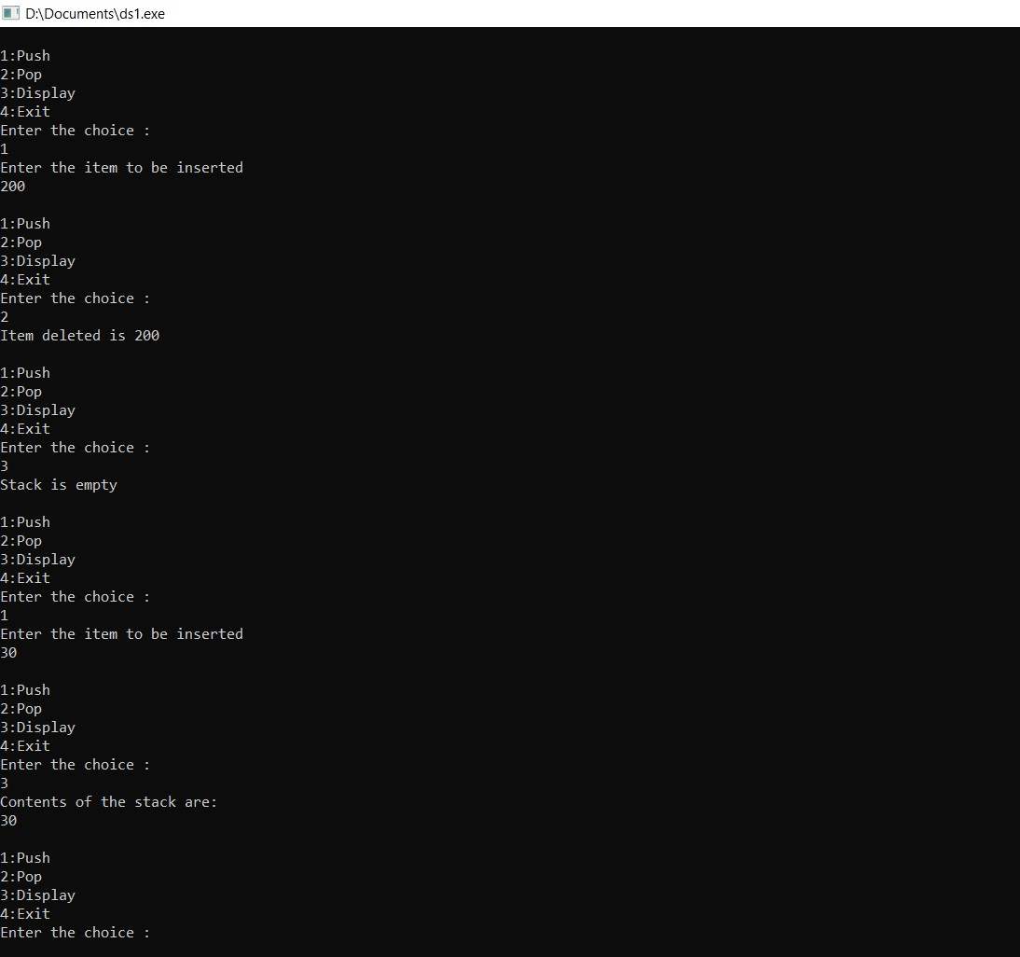

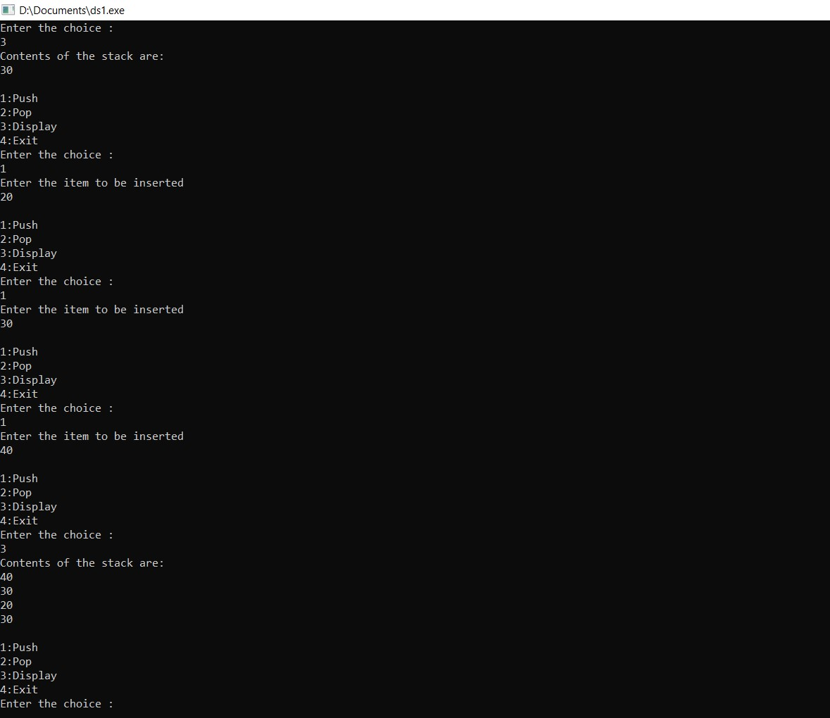

# LAB PROGRAM 2

**WAP to convert a given valid parenthesized infix arithmetic expression to postfix expression. The expression consists of single character operands and the binary operators + , - , * and /**

#include<stdio.h>

#include<stdlib.h> #include<string.h> int fun1(char symbol)

{ switch(symbol)

{ case '+' :

case '-' : return 2; case '*' :

case '/' : return 4; case '^' :

case '$' : return 5; case '(' : return 0; case '#' : return -1; default : return 8;

} } int fun2(char symbol)

{ switch(symbol)

{ case '+' :

case '-' : return 1; case '*' :

case '/' : return 3; case '^' :

case '$' : return 6; case '(' : return 9; case ')' : return 0; default : return 7;

} }

void infix_postfix(char infix[],char postfix[])

{ int top,j,i; char s[30]; char symbol; top=-1; s[++top]='#'; j=0; for(i=0;i<strlen(infix);i++)

{ symbol=infix[i]; while(fun1(s[top])>fun2(symbol))

{ postfix[j]=s[top--]; j++; } if(fun1(s[top])!=fun2(symbol))

{ s[++top]=symbol;

}

else top--; } while(s[top]!='#') { postfix[j++]=s[top--]; } postfix[j]='\0'; } void main() { char infix[20],postfix[20]; int a=0,b=0,k; printf("Enter a valid infix expression:\n"); scanf("%s",infix); for(k=0;k<strlen(infix);k++)

{ if(infix[k]=='(') a++; else if(infix[k]==')') b++; else continue; } if(a!=b) { printf("Invalid infix expression"); exit(0);

} infix_postfix(infix,postfix); printf("The postfix expression is: \n"); printf("%s\n",postfix);

}

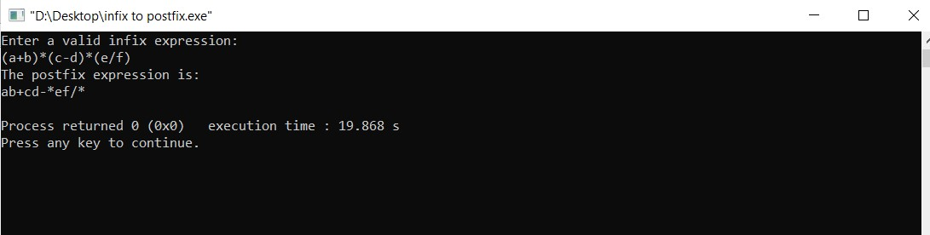

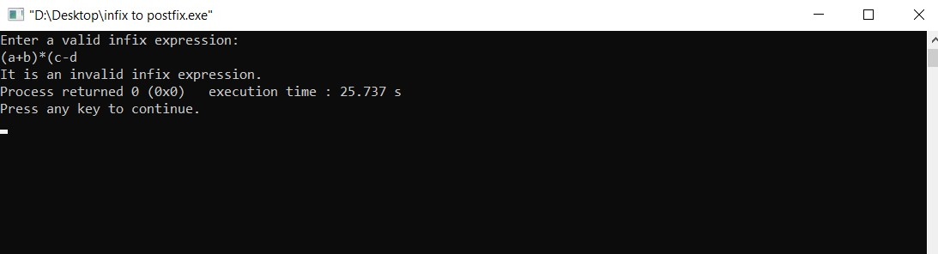

# LAB PROGRAM 3

**Write a program to simulate the working of a queue of integers using an array. Provide the following operations:**

1. **Insert**
2. **Delete**
3. **Display**

**The program should print appropriate messages for queue empty and queue overflow conditions.**

#include<stdio.h>

#include<stdlib.h> #define queue_size 3

int item,front=0,rear=-1,q[10]; void insertrear()

{

if(rear==queue_size-1)

{

printf("Queue overflow.\n"); return;

} rear=rear+1; q[rear]=item;

} int delfront()

{

if(front>rear)

{ front=0; rear=-1; return -1;

}

return q[front++];

} void display() {

int i; if(front>rear)

{

printf("Queue is empty.\n");

return;

} printf("Contents of queue are : \n"); for(i=front;i<=rear;i++)

{

printf("%d\n",q[i]);

} } int main() { int choice; for(;;)

{

printf("\n1:Insertrear \n2:Deletefront \n3:Display \n4:Exit\n"); printf("Enter the choice :"); scanf("%d",&choice); switch(choice)

{

case 1:printf("Enter the item to be inserted:\n");

scanf("%d",&item);

insertrear(); break; case 2:item=delfront(); if(item==-1) printf("Queue is empty.\n"); else printf("Item deleted is %d\n",item); break; case 3:display(); break; default:exit(0);

}

}

}

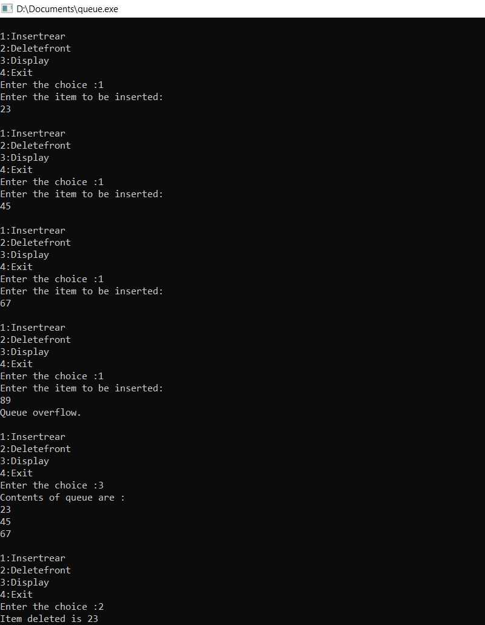

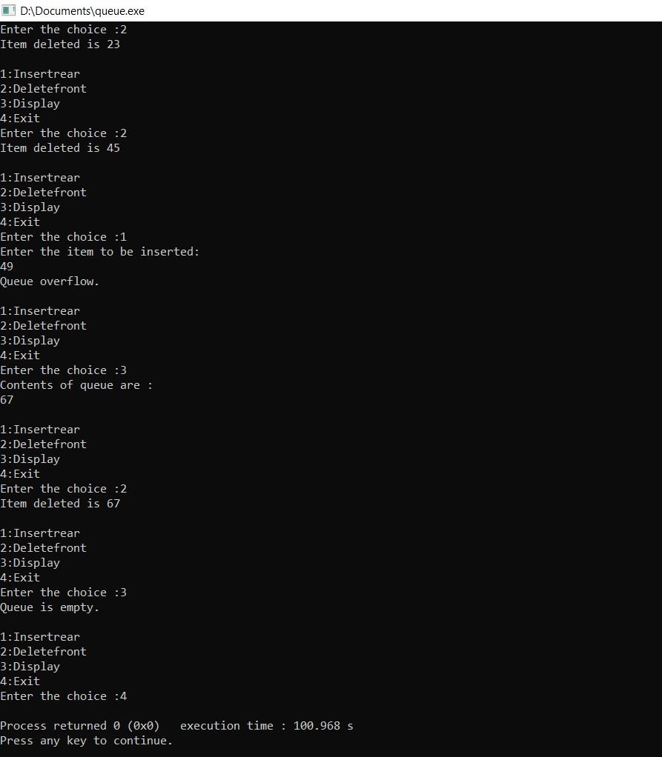

# LAB PROGRAM 4

**Write a program to simulate the working of a circular queue of integers using an array. Provide the following operations:**

1. **Insert**
2. **Delete**
3. **Display**

**The program should print appropriate messages for queue empty and queue overflow conditions.**

#include<stdio.h>

#include<stdlib.h>

#include<process.h> #define queue_size 3 int item, front = 0, rear = -1, q[queue_size], count = 0; void insertrear ()

{ if (count == queue_size)

{

printf ("Queue overflow."); return;

}

rear = (rear + 1) % queue_size; q[rear] = item; count++;

}

int deletefront ()

{

if (count == 0) return -1; item = q[front]; front = (front + 1) % queue_size; count = count - 1; return item; } void display ()

{

int i, f;

if (count == 0)

{

printf ("The queue is empty."); return; } f = front; printf ("Contents of the queue are : \n"); for (i = 0; i <= count; i++)

{ printf ("%d\n", q[f]); f = (f + 1) % queue_size;

}

} void main () { int choice; for (;;)

{

printf ("\n1.Insert rear \n2.Delete front \n3.Display \n4.Exit \n"); printf ("Enter the choice : "); scanf ("%d", &choice); switch (choice)

|  |  |
| --- | --- |
| }  } | { case 1:  printf ("Enter the item to be inserted :"); scanf ("%d", &item); insertrear (); break; case 2:  item = deletefront (); if (item == -1) printf ("Queue is empty.\n"); else  printf ("Item deleted is %d.\n", item); break; case 3: display (); break; default: exit (0);  }  19 |

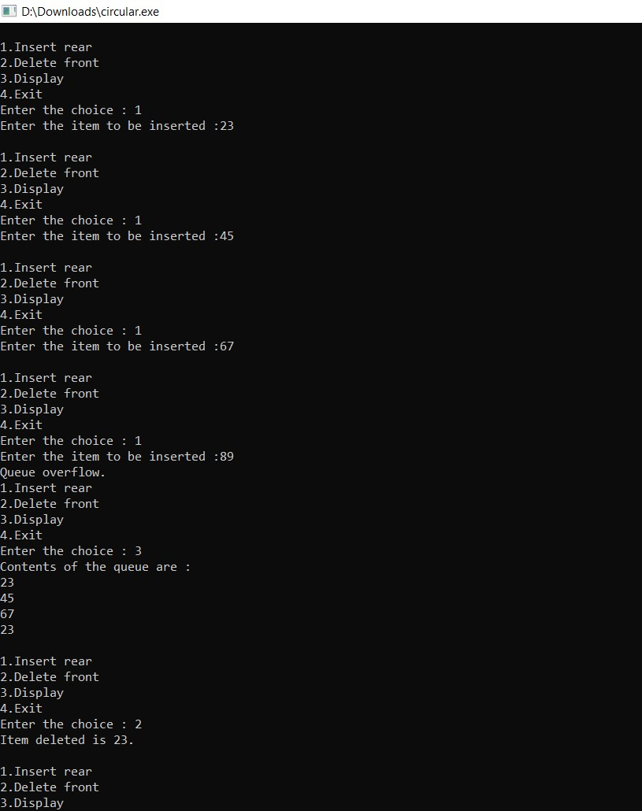

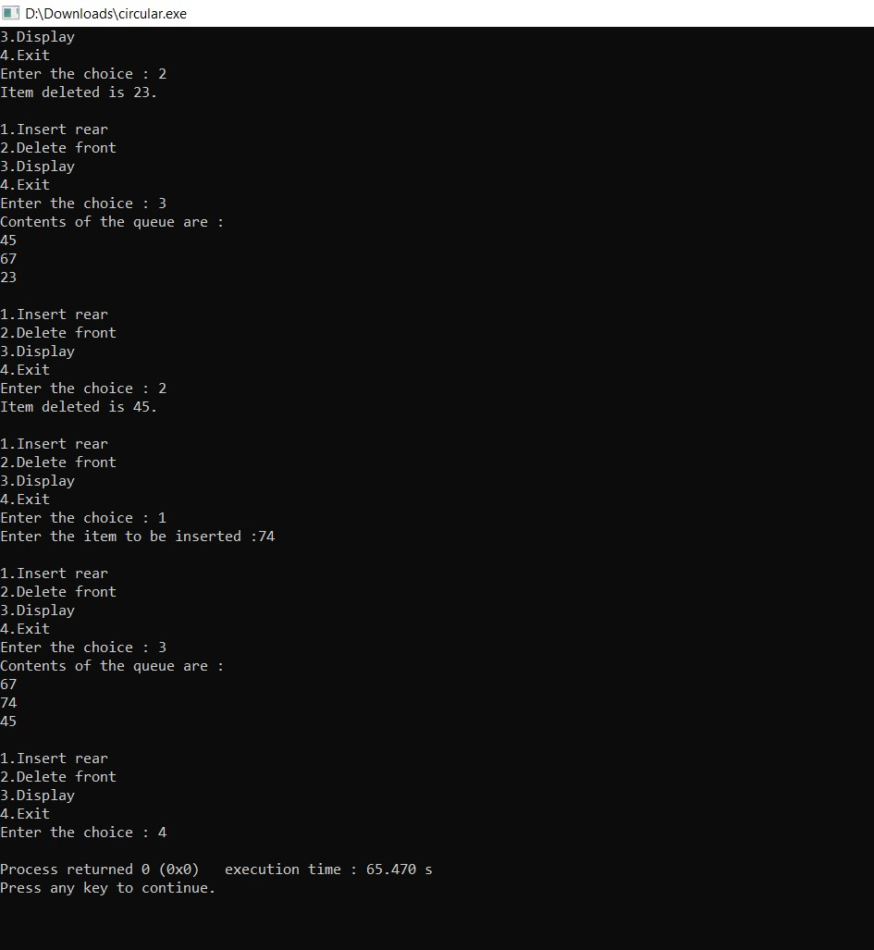

# LAB PROGRAMS 5 & 6

**Write a program to implement a Singly Linked List with following**

**operations:**

1. **Create a linked list**
2. **Insertion of a node at first position, at any position and at end of the list**
3. **Deletion of first element, specified element and last element in the list**
4. **Display the contents of the linked list**

#include<stdio.h> #include<process.h> struct node

{ int data; struct node *next;

};

struct node *head; void beg_insert ()

{

struct node *ptr; int item; ptr = (struct node *) malloc (sizeof (struct node)); if (ptr == NULL)

{ printf ("\nList overflow");

} else {

printf ("\nEnter the value : "); scanf ("%d", &item); ptr->data = item;

ptr->next = head; head = ptr;

printf ("\nNode is inserted at the front.");

} } void end_insert () { struct node *ptr, *temp; int item; ptr = (struct node *) malloc (sizeof (struct node)); if (ptr == NULL)

{ printf ("\nList overflow");

} else { printf ("\nEnter the value : "); scanf ("%d", &item); ptr->data = item; if (head == NULL)

{

ptr->next = NULL; head = ptr; printf ("\nNode is inserted.");

}

else

{

temp = head;

while (temp->next != NULL)

{

temp = temp->next;

} temp->next = ptr; ptr->next = NULL; printf ("\nNode is inserted at the end.");

}

} } void random_insert ()

{ int i, loc, item; struct node *ptr, *temp;

ptr = (struct node *) malloc (sizeof (struct node)); if (ptr == NULL)

{ printf ("\nList overflow");

} else {

printf ("\nEnter the value : "); scanf ("%d", &item); ptr->data = item;

printf("\nEnter the location of the node after which you want to insert : "); scanf ("%d", &loc); temp = head; for (i = 0; i < loc; i++)

{

temp = temp->next; if (temp == NULL) {

printf ("\nCant insert node."); return;

}

}

ptr->next = temp->next; temp->next = ptr; printf ("\nNode is inserted at the specified position.");

} } void beg_delete ()

{ struct node *ptr; if (head == NULL)

{

printf ("\nList is empty");

} else { ptr = head; head = ptr->next; free (ptr); printf ("\nNode is deleted from the front.");

}

}

void end_delete () { struct node *ptr, *ptr1; if (head == NULL)

{

printf ("\nList is empty");

}

else if (head->next == NULL)

{

head = NULL; free (head);

printf ("\nThe only node of the list is deleted.");

} else { ptr = head; while (ptr->next != NULL)

{

ptr1 = ptr; ptr = ptr->next;

}

ptr1->next = NULL;

free (ptr);

printf ("\nNode is deleted from the end.");

} } void random_delete ()

{

struct node *ptr, *ptr1; int loc, i;

printf("\nEnter the location of the node after which you want to perform deletion : "); scanf ("%d", &loc); ptr = head; for (i = 0; i < loc; i++)

{ ptr1 = ptr; ptr = ptr->next; if (ptr == NULL)

{

printf ("\nCant delete"); return;

}

} ptr1->next = ptr->next; free (ptr); printf ("\nNode is deleted from the specified position %d", loc + 1);

} void display ()

{

struct node *ptr; ptr = head; if (ptr == NULL)

{ printf ("\nNothing to print. List is empty.");

} else { printf ("\nList values are : "); while (ptr != NULL)

{

printf ("\n%d", ptr->data); ptr = ptr->next;

}

} } void main ()

{

int choice = 0; while (choice != 8)

{

printf ("\nChoose an option"); printf("\n1.Insert at front \n2.Insert at end \n3.Insert at specified position \n4.Delete from front \n5.Delete from end \n6.Delete from specified position \n7.Display list contents

\n8.Exit");

printf ("\nEnter your choice : "); scanf ("%d", &choice); switch (choice)

{

case 1:beg_insert (); break;

case 2:end_insert (); break; case 3:random_insert (); break;

|  |  |
| --- | --- |
| }  } | case 4:beg_delete (); break; case 5:end_delete (); break;  case 6:random_delete ();  break; case 7:display (); break; case 8:exit (0); default:exit (0);  }  29 |

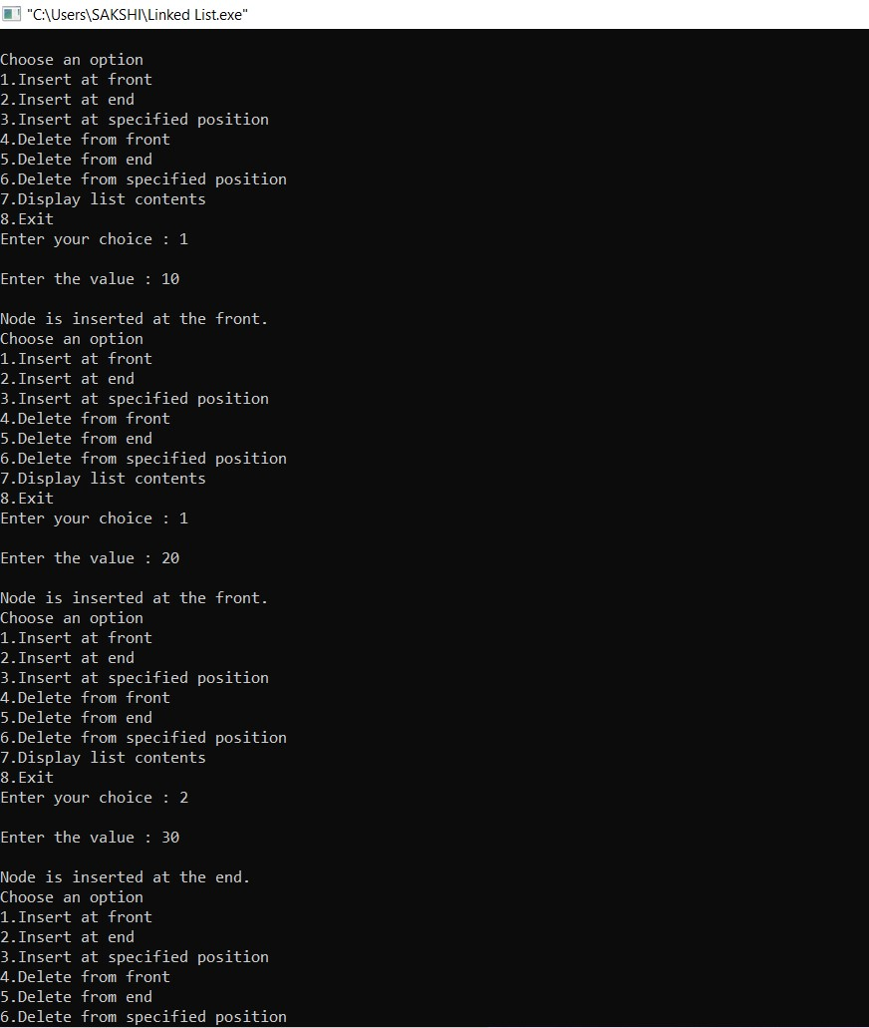

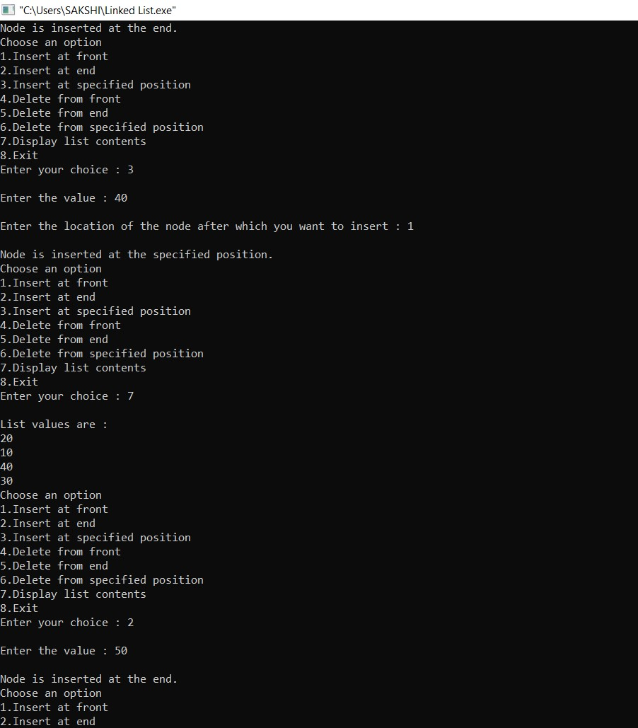

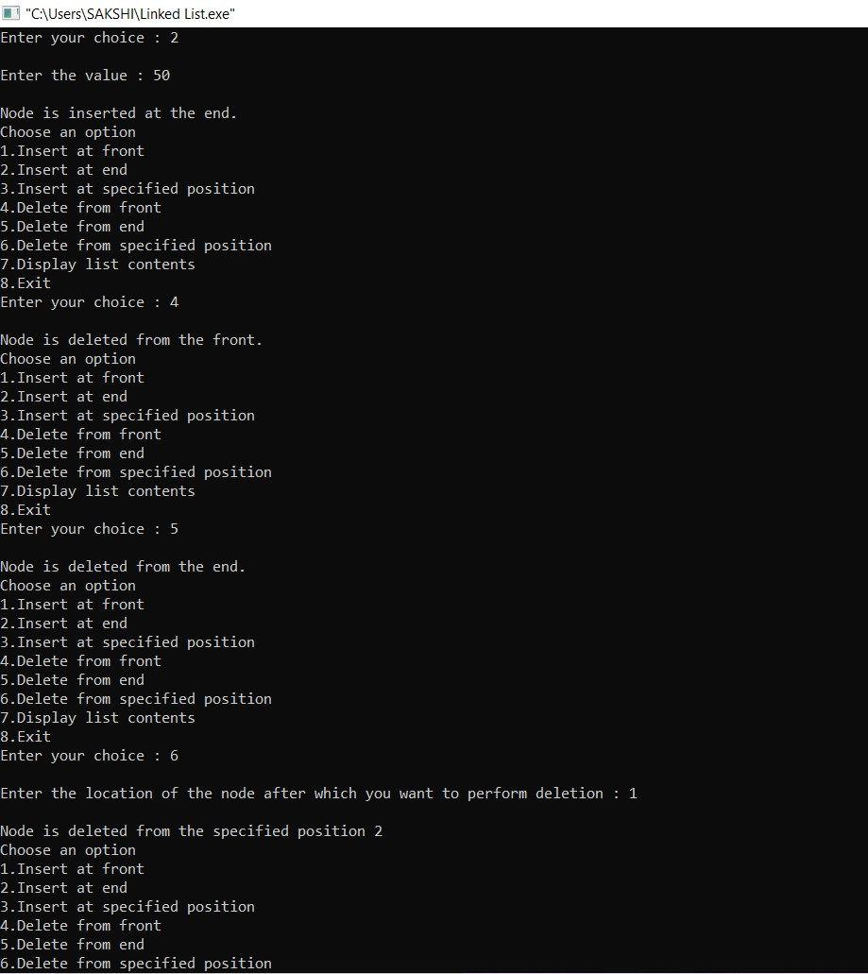

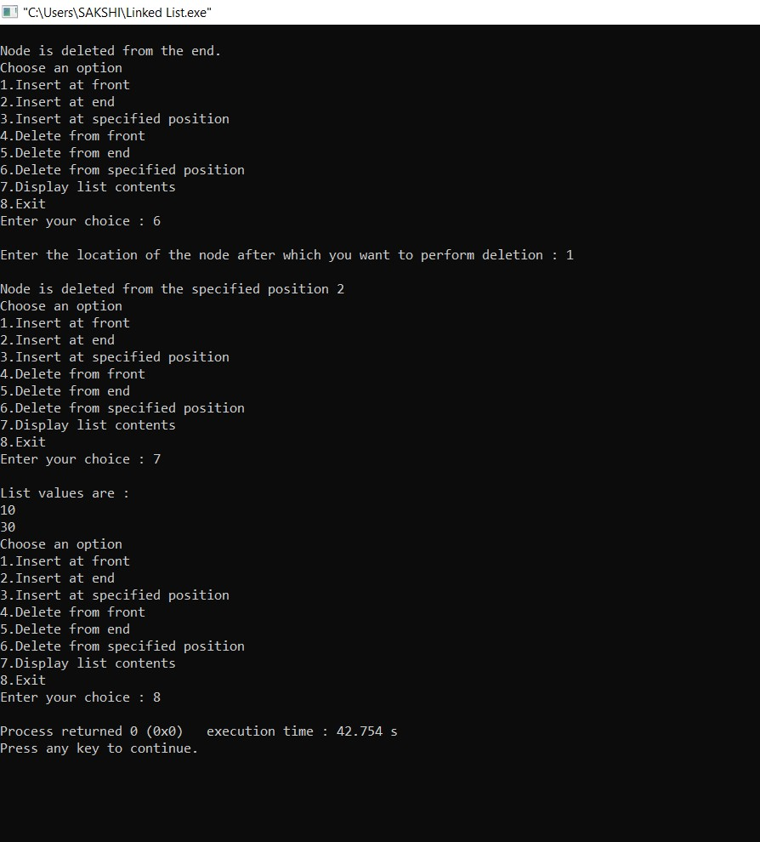

# LAB PROGRAM 7

**Write a program to implement Single Linked List with following operations**

1. **Sort the linked list**
2. **Reverse the linked list c) Concatenation of two linked lists**

#include<stdio.h>

#include<conio.h> #include<process.h> struct node

{ int info; struct node *link;

};

typedef struct node *NODE;

NODE getnode()

{

NODE x; x = (NODE)malloc(sizeof(struct node)); if(x==NULL)

{

printf("\nMemory is full\n"); exit(0);

} return x;

}

NODE insert_front(NODE first,int item)

{

NODE temp; temp=getnode(); temp->info=item; temp->link=NULL; if(first==NULL)

{ return temp;

}

temp->link=first; first=temp; return first;

}

NODE delete_front(NODE first)

{

NODE temp; if(first==NULL)

{

printf("List is empty. Cannot delete\n"); return first;

} temp=first; temp = temp->link;

printf("Item deleted at front end is %d\n",first->info); free(first); return temp;

}

NODE IF(NODE second,int item)

{

NODE temp; temp=getnode(); temp->info=item; temp->link=NULL; if(second==NULL)

return temp; temp->link=second; second=temp; return second;

}

NODE IR(NODE second,int item)

{

NODE temp,cur; temp=getnode(); temp->info=item; temp->link=NULL; if(second==NULL)

return temp; cur=second; while(cur->link!=NULL) cur=cur->link; cur->link=temp; return second; }

NODE reverse(NODE first)

{ NODE cur,temp; cur=NULL; while(first!=NULL)

{

temp=first; first=first->link; temp->link=cur; cur=temp;

} return cur;

}

NODE ascending(NODE first)

{

NODE prev=first; NODE cur=NULL; int temp; if(first== NULL)

{

return 0;

}

else

{

while(prev!= NULL)

{

cur = prev->link; while(cur!= NULL)

{

if(prev->info > cur->info)

{

temp = prev->info; prev->info = cur->info; cur->info = temp;

} cur = cur->link; } prev= prev->link;

}

}

return first;

}

NODE descending(NODE first)

{

NODE prev=first; NODE cur=NULL; int temp; if(first==NULL)

{

return 0;

}

else

{

while(prev!= NULL)

{

cur = prev->link; while(cur!= NULL)

{

if(prev->info < cur->info)

{ temp = prev->info; prev->info = cur->info; cur->info = temp; } cur = cur->link; } prev= prev->link;

}

} return first;

}

NODE concatenate(NODE first,NODE second)

{ NODE cur; if(first==NULL) return second; if(second==NULL)

return first; cur=first;

while(cur->link!=NULL)

{ cur=cur->link;

}

cur->link=second; return first; } void display(NODE first)

{

NODE temp; if(first==NULL) printf("List is empty. Cannot display items.\n"); printf("List contents are : ");

for(temp=first;temp!=NULL;temp=temp->link)

{

printf("\n%d",temp->info);

}

} void main()

{

int item,choice,pos,element,option,choice2,item1,num;

NODE first=NULL; NODE second=NULL;

for(;;)

{

printf("\n\nChoose an option"); printf("\n1:Insert_front \n2:Delete_front \n3:Reverse \n4:Sort \n5.Concatenate \n6:Display

\n7:Exit\n"); printf("Enter the choice : "); scanf("%d",&choice); switch(choice)

{

case 1: printf("Enter the item at front-end : "); scanf("%d",&item); first=insert_front(first,item); printf("%d inserted at front-end.",first->info); break;

case 2: first=delete_front(first); break; case 3: first=reverse(first); printf("List is reversed."); break;

case 4: printf("Press 1 for Ascending-sort and 2 for Descending-sort : "); scanf("%d",&option); if(option==1)

{ first=ascending(first); printf("List is sorted in ascending order.");

} if(option==2)

{

first=descending(first); printf("List is sorted in descending order.");

} break; case 5: printf("Create a second list\n"); printf("Enter the number of elements in the second list : "); scanf("%d",&num); for(int i=1;i<=num;i++)

{

printf("\nPress 1 to Insert-front and 2 to Insert-rear : "); scanf("%d",&choice2); if(choice2==1)

{

printf("Enter the item at front-end : "); scanf("%d",&item1); second=IF(second,item1);

}

if(choice2==2)

{

printf("Enter the item at rear-end : "); scanf("%d",&item1); second=IR(second,item1);

}

}

first=concatenate(first,second); printf("\nThe two lists are concatenated."); break; case 6: display(first); break; default: exit(0); break;

}

}

}

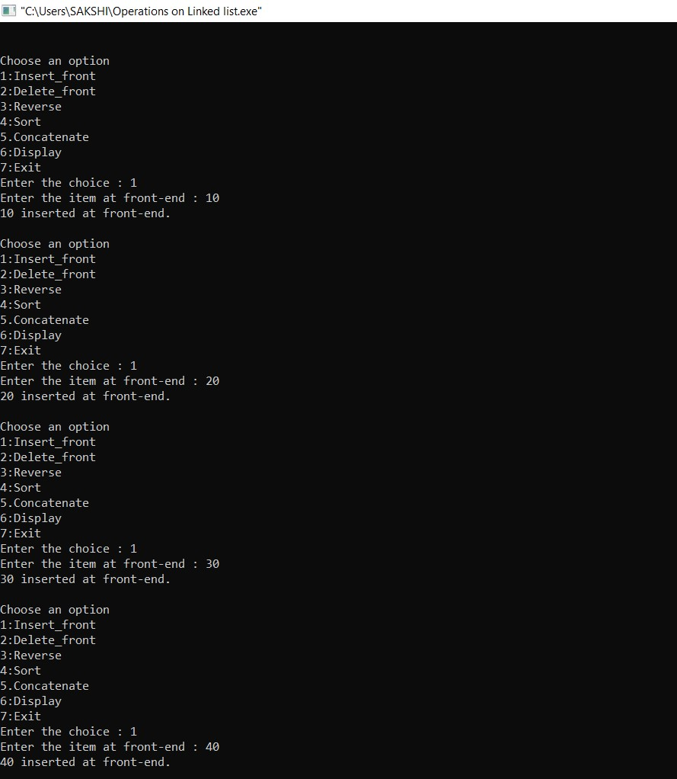

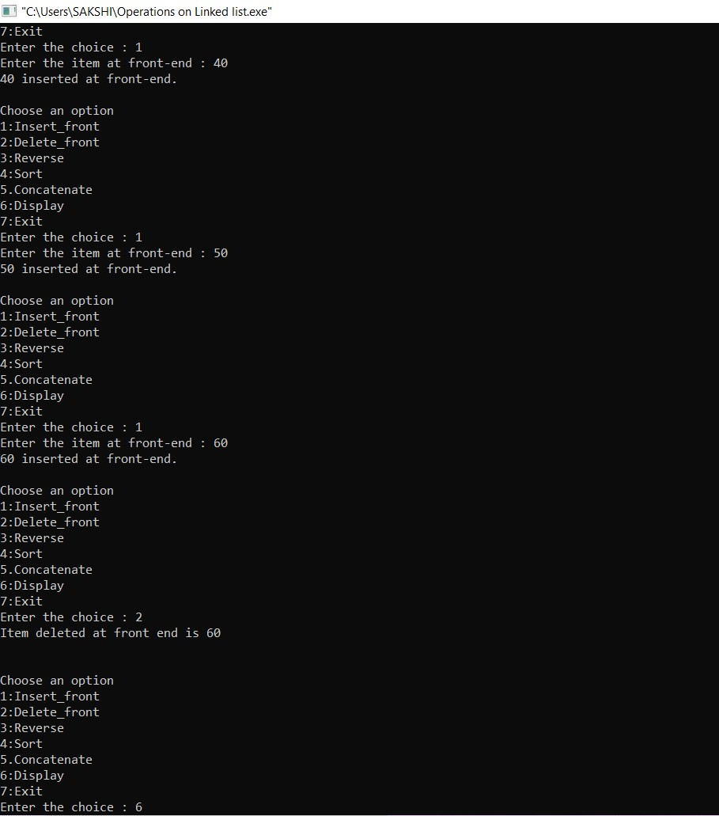

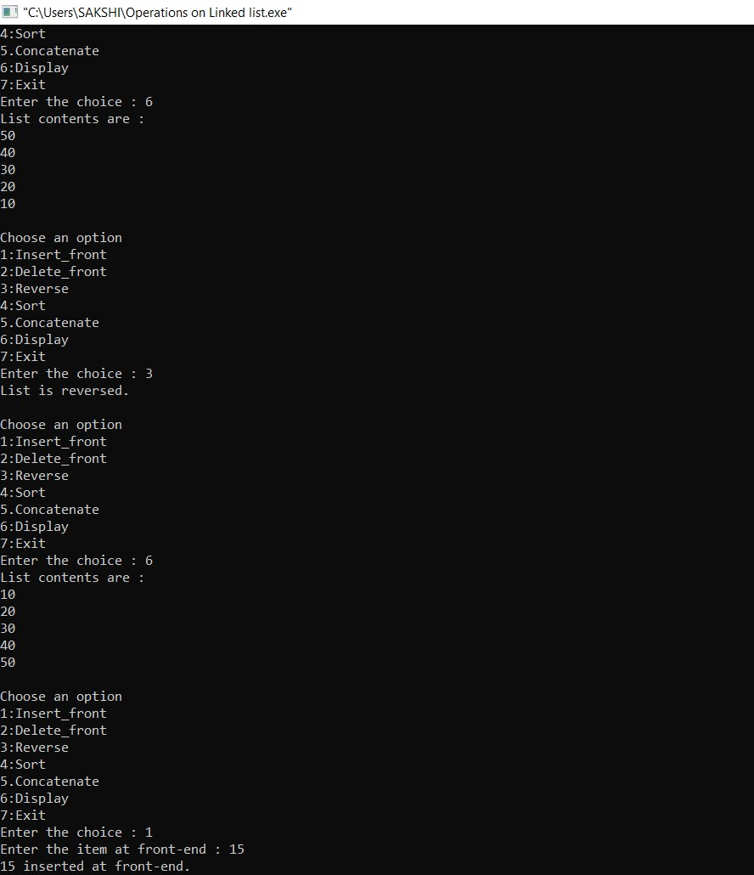

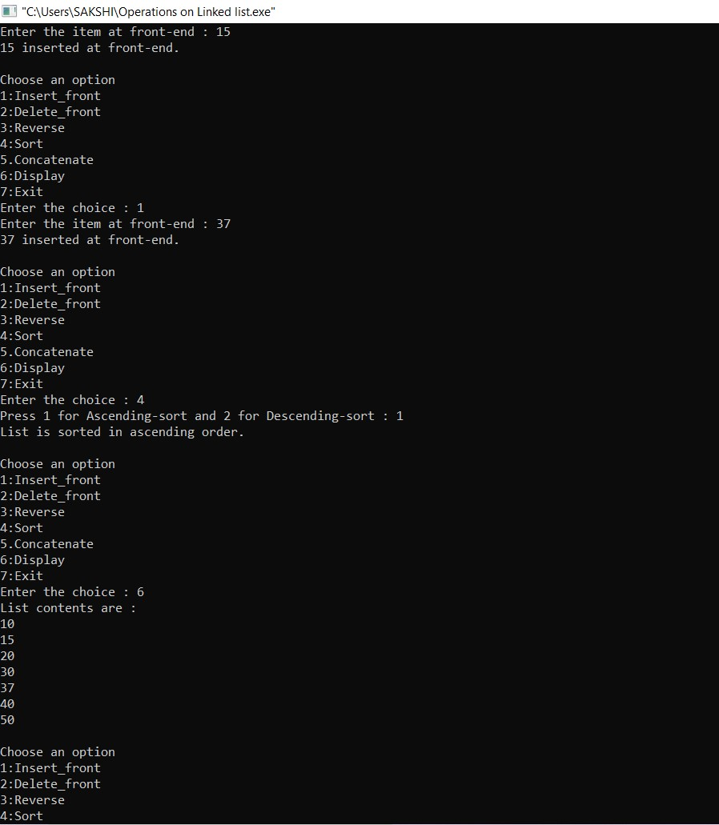

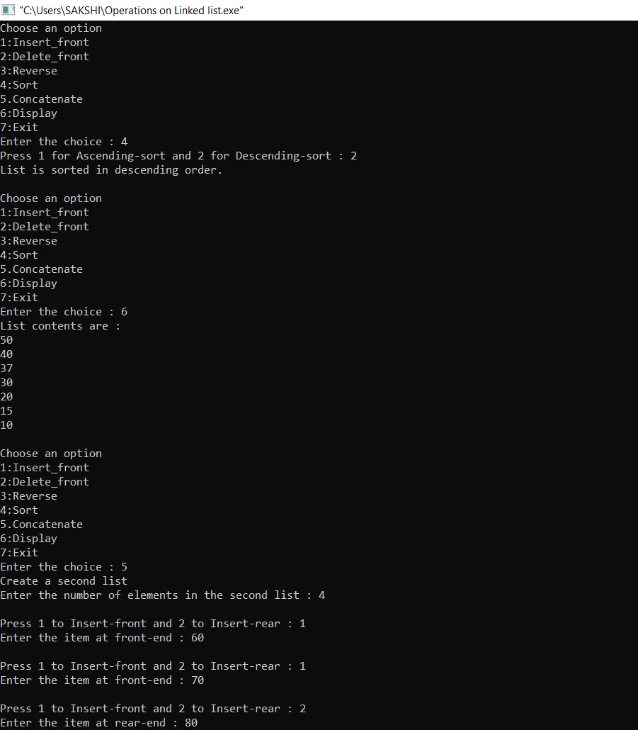

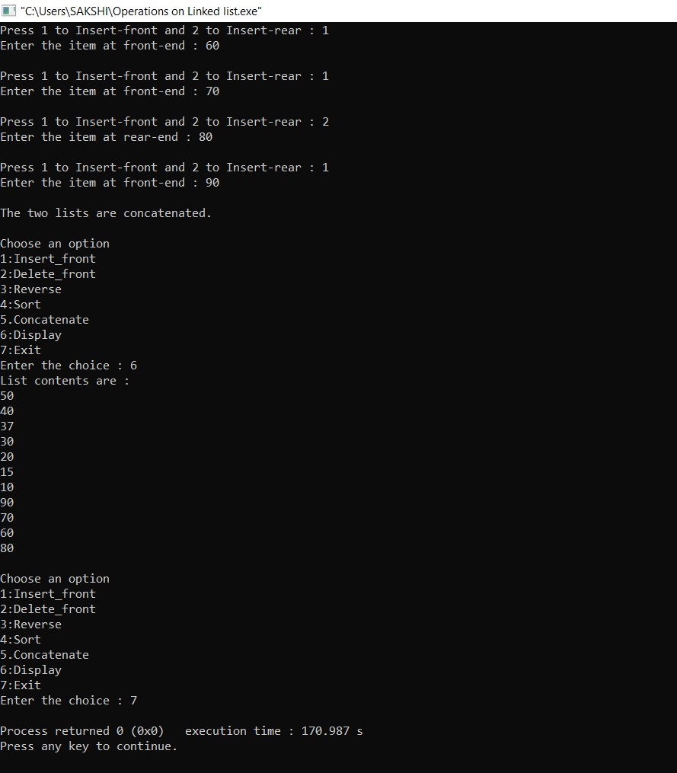

# LAB PROGRAM 8

**Write a program to implement Stacks using Linked List representation**

#include <stdio.h> #include <stdlib.h> void push(); void pop(); void display(); struct node { int val; struct node *next;

}; struct node *head; void main ()

{ int choice=0; while(choice != 4)

{

printf("\n1.Push\n2.Pop\n3.Display\n4.Exit"); printf("\nEnter your choice: "); scanf("%d",&choice); switch(choice)

{ case 1: { push(); break;

}

case 2: { pop(); break; } case 3: { display(); break; } case 4: { printf("Exit"); break; } default:

{

printf("Please Enter valid choice.\n");

}

}

}

} void push () { int val; struct node *ptr = (struct node *)malloc(sizeof(struct node)); if(ptr == NULL)

{

printf("Memory is full.");

} else { printf("Enter the value: "); scanf("%d",&val); if(head==NULL)

{ ptr->val = val; ptr -> next = NULL; head=ptr; } else { ptr->val = val; ptr->next = head; head=ptr;

}

printf("Value is pushed into the stack.\n");

}

} void pop() { int item; struct node *ptr; if (head == NULL)

{

printf("Stack Underflow\n");

} else

{ item = head->val; ptr = head; head = head->next; printf("%d is popped from the stack.\n",item); free(ptr);

}

} void display()

{

int i; struct node *ptr; ptr=head; if(ptr == NULL)

{ printf("Stack is empty.\n");

} else

{

printf("Contents of the stack: \n"); while(ptr!=NULL)

{

printf("%d\n",ptr->val); ptr = ptr->next;

}

}

}

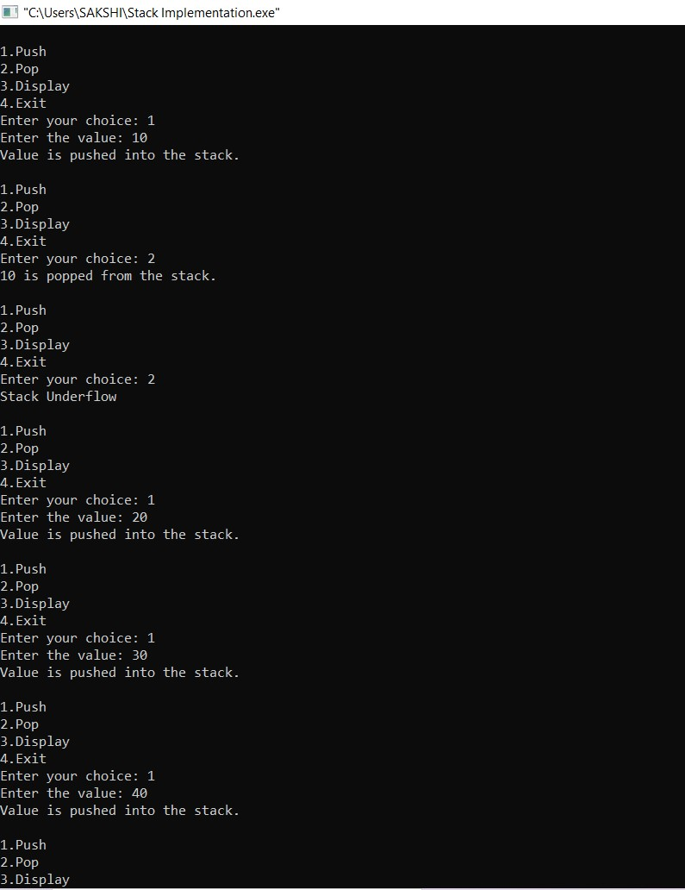

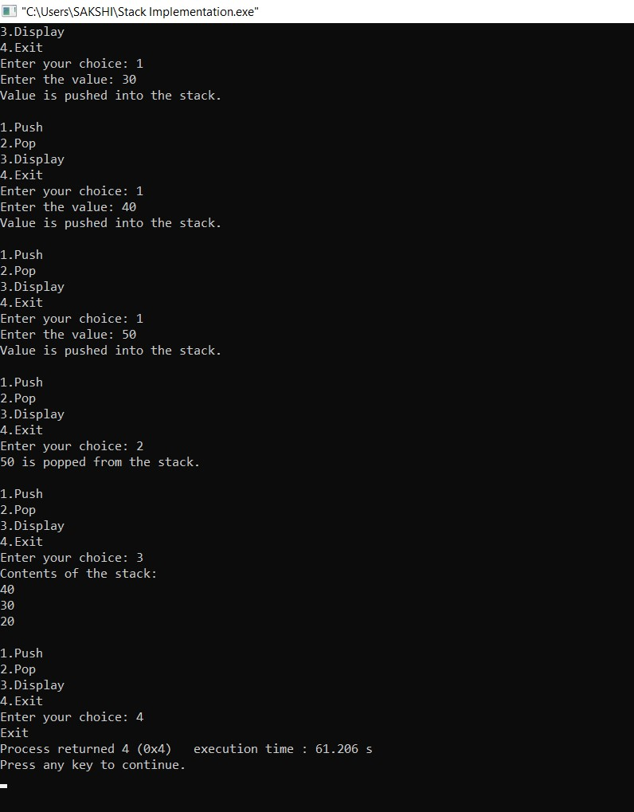

**Write a program to implement Queues using Linked List representation**

#include<stdio.h> #include<stdlib.h> struct node

{ int data; struct node *next;

}; struct node *front; struct node *rear; void insert(); void deleteq(); void display(); int main () { int choice; while(choice != 4)

{

printf("\n1.Insert rear\n2.Delete front\n3.Display\n4.Exit\n"); printf("Enter your choice: "); scanf("%d",&choice); switch(choice)

{ case 1:

insertq(); break; case 2:

deleteq();

break; case 3: display(); break; case 4: exit(0); break; default:

printf("Enter valid choice.\n");

}

}

} void insertq() { struct node *ptr; int item; ptr = (struct node *) malloc (sizeof(struct node)); if(ptr == NULL)

{

printf("Queue Overflow\n"); return; } else {

printf("Enter the value: "); scanf("%d",&item); ptr -> data = item; if(front == NULL)

{ front = ptr; rear = ptr; front -> next = NULL; rear -> next = NULL;

} else { rear -> next = ptr; rear = ptr; rear->next = NULL;

}

}

} void deleteq() { struct node *ptr; if(front == NULL)

{

printf("Queue Underflow.\n"); return; } else { ptr = front; front = front -> next; printf("%d is deleted from the queue.\n",ptr->data); free(ptr);

}

} void display() { struct node *ptr; ptr = front; if(front == NULL)

{

printf("Queue is empty.\n");

} else

{ printf("Contents of the queue are:\n"); while(ptr != NULL)

{

printf("%d\n",ptr -> data); ptr = ptr -> next;

}

}

}

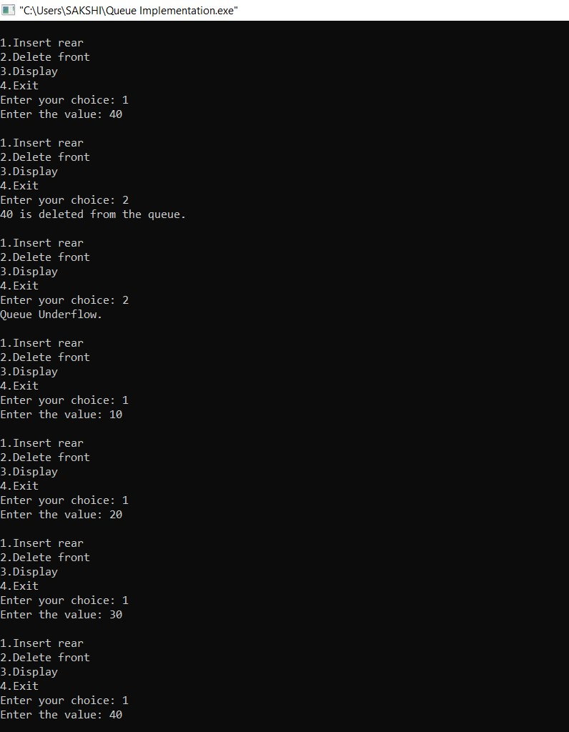

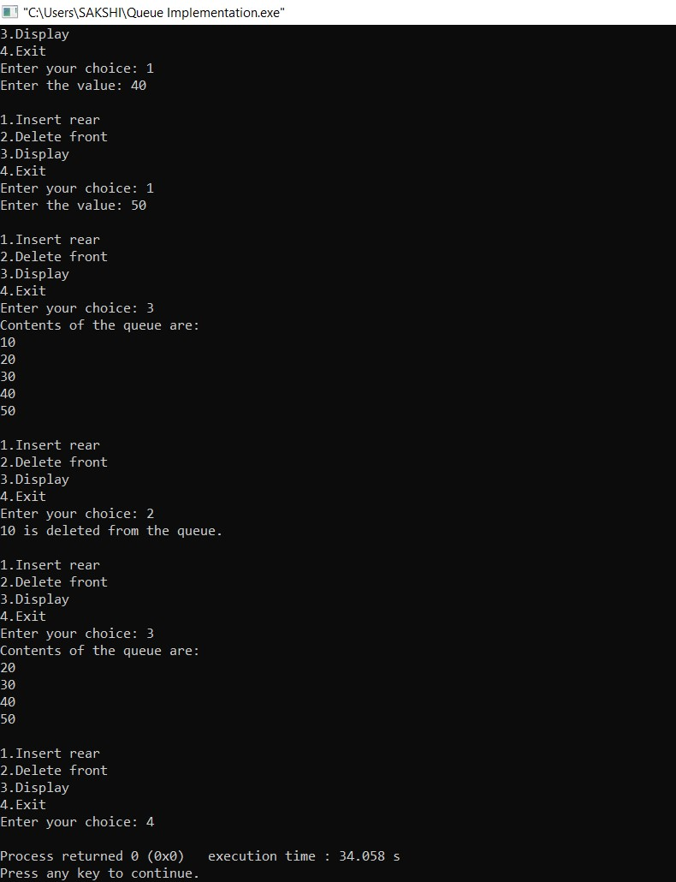

# LAB PROGRAM 9

**Write a program to implement doubly linked list with primitive operations:**

1. **Create a doubly linked list**
2. **Insert nodes at both ends**
3. **Delete nodes at both ends**
4. **Insert a new node to the left of the specified node**
5. **Insert a new node to the right of the specified node**
6. **Delete all key elements**
7. **Display the contents of the list**

#include<stdio.h> #include<process.h> struct node

{

int info; struct node *llink; struct node *rlink;

};

typedef struct node *NODE;

NODE getnode()

{

NODE x;

x=(NODE)malloc(sizeof(struct node));

if(x==NULL)

{

printf("Memory is full.\n");

exit(0);

}

return x;

} void freenode(NODE x) {

free(x);

}

NODE dinsert_front(int item,NODE head)

{

NODE temp,cur; temp=getnode(); temp->info=item; cur=head->rlink; head->rlink=temp; temp->llink=head; temp->rlink=cur; cur->llink=temp; return head;

}

NODE dinsert_rear(int item,NODE head)

{

NODE temp,cur; temp=getnode(); temp->info=item; cur=head->llink; head->llink=temp; temp->rlink=head; temp->llink=cur; cur->rlink=temp; return head;

}

NODE ddelete_front(NODE head)

{ NODE cur,next; if(head->rlink==head)

{ printf("List is empty.\n"); return head;

}

cur=head->rlink; next=cur->rlink; head->rlink=next; next->llink=head; printf("Node deleted is %d",cur->info); freenode(cur); return head;

}

NODE ddelete_rear(NODE head)

{ NODE cur,prev; if(head->rlink==head)

{ printf("List is empty.\n"); return head;

}

cur=head->llink; prev=cur->llink; head->llink=prev; prev->rlink=head; printf("Node deleted is %d",cur->info); freenode(cur); return head;

}

NODE insert_leftpos(int item,NODE head)

{

NODE temp,cur,prev; if(head->rlink==head)

{

printf("List is empty.\n"); return head;

}

cur=head->rlink; while(cur!=head)

{

if(item==cur->info) break; cur=cur->rlink;

}

if(cur==head)

{

printf("Key not found.\n"); return head;

}

prev=cur->llink; printf("Enter towards left of %d = ",item); temp=getnode(); scanf("%d",&temp->info); prev->rlink=temp;

temp->llink=prev; cur->llink=temp; temp->rlink=cur; return head;

}

NODE insert_rightpos(int item,NODE head)

{

NODE temp,cur,prev; if(head->rlink==head)

{ printf("List is empty.\n"); return head;

}

cur=head->llink; while(cur!=head)

{

if(item==cur->info) break; cur=cur->llink;

}

if(cur==head)

{

printf("Key not found.\n"); return head;

}

prev=cur->rlink; printf("Enter towards right of %d = ",item); temp=getnode();

scanf("%d",&temp->info); prev->llink=temp; temp->rlink=prev; cur->rlink=temp; temp->llink=cur; return head;

}

NODE delete_all_key(int item,NODE head)

{

NODE prev,cur,next; int count; if(head->rlink==head)

{ printf("List is empty."); return head;

}

count=0; cur=head->rlink; while(cur!=head)

{ if(item!=cur->info) cur=cur->rlink; else { count++; prev=cur->llink; next=cur->rlink; prev->rlink=next; next->llink=prev; freenode(cur); cur=next;

}

}

if(count==0) printf("Key not found."); else

printf("Key found at %d positions and are deleted.\n", count); return head;

}

void display(NODE head)

{

NODE temp; if(head->rlink==head)

{ printf("List is empty.\n"); return; }

printf("Contents of the list : \n"); temp=head->rlink; while(temp!=head)

{

printf("%d ",temp->info); temp=temp->rlink;

} printf("\n");

}

void main()

{

NODE head,last; int item, choice; head=getnode(); head->rlink=head; head->llink=head;

for(;;)

{

printf("\n1:Insert front\n2:Insert rear\n3:Delete front\n4:Delete rear\n5:Insert left position\n6:Insert right position\n7:Delete all key elements\n8:Display\n9:Exit\n"); printf("Enter the choice : "); scanf("%d",&choice); switch(choice)

{

case 1: printf("Enter the item to be inserted at front end : "); scanf("%d",&item); last=dinsert_front(item,head); break;

case 2: printf("Enter the item to be inserted at rear end : "); scanf("%d",&item); last=dinsert_rear(item,head); break;

case 3: last=ddelete_front(head); break; case 4: last=ddelete_rear(head); break; case 5: printf("Enter the key item : "); scanf("%d",&item); head=insert_leftpos(item,head); break;

case 6: printf("Enter the key item : "); scanf("%d",&item); head=insert_rightpos(item,head); break; case 7: printf("Enter the key item : "); scanf("%d",&item); head=delete_all_key(item,head); break; case 8: display(head); break; default: exit(0);

}

}

}

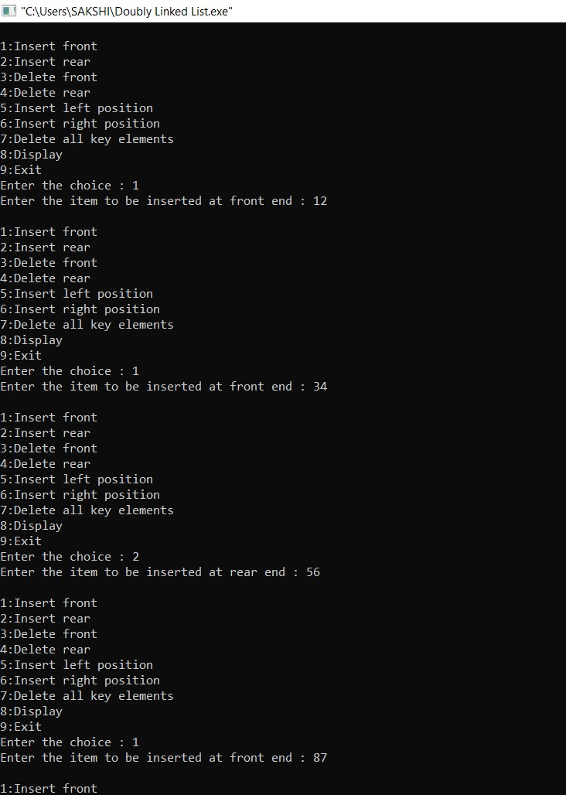

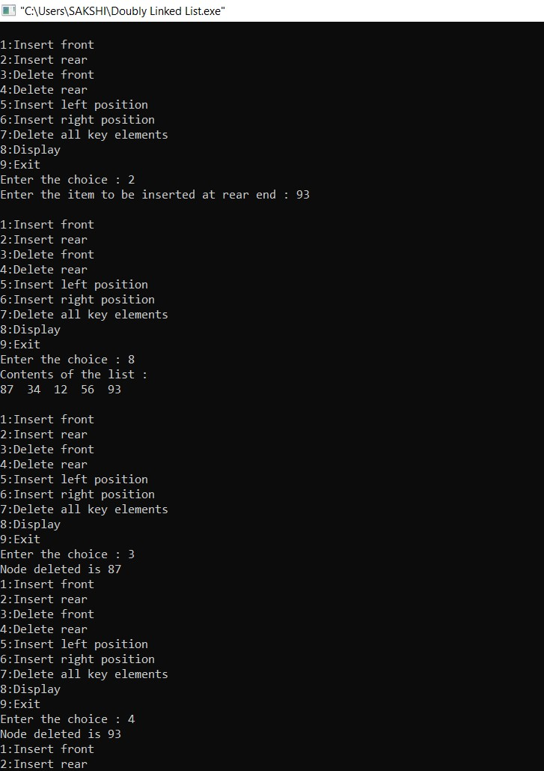

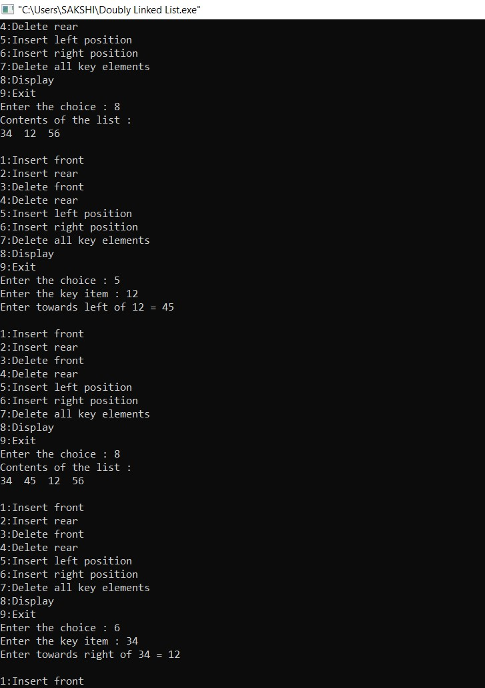

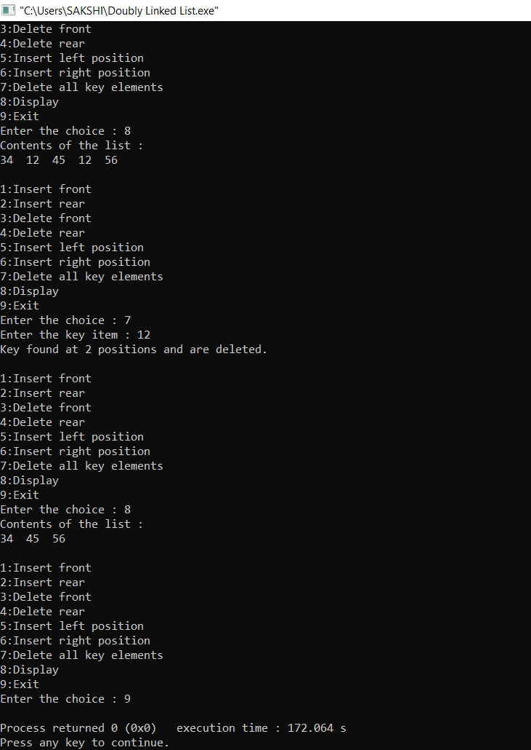

# LAB PROGRAM 10

**Write a program**

1. **To construct a Binary Search Tree**
2. **To traverse the tree using all the methods, i.e., in order, pre order and post**

**order**

1. **To display the elements in the tree**

#include<stdio.h> #include<process.h> struct node

{ int info; struct node *rlink; struct node *llink;

};

typedef struct node *NODE;

NODE getnode()

{

NODE x; x=(NODE)malloc(sizeof(struct node)); if(x==NULL)

{ printf("Memory is full.\n"); exit(0);

} return x;

} void freenode(NODE x)

{ free(x); }

NODE insert(NODE root,int item)

{

NODE temp,cur,prev; temp=getnode(); temp->rlink=NULL; temp->llink=NULL; temp->info=item; if(root==NULL) return temp; prev=NULL; cur=root; while(cur!=NULL)

{ prev=cur; cur=(item<cur->info)?cur->llink:cur->rlink;

}

if(item<prev->info) prev->llink=temp; else prev->rlink=temp; return root;

}

NODE delete(NODE root,int item)

{

NODE cur,parent,q,suc; if(root==NULL)

{

printf("Empty\n"); return root;

}

parent=NULL; cur=root; while(cur!=NULL&&item!=cur->info)

{ parent=cur;

cur=(item<cur->info)?cur->llink:cur->rlink;

}

if(cur==NULL)

{ printf("Not found.\n"); return root;

}

if(cur->llink==NULL) q=cur->rlink; else if(cur->rlink==NULL) q=cur->llink; else

{ suc=cur->rlink; while(suc->llink!=NULL) suc=suc->llink; suc->llink=cur->llink; q=cur->rlink;

}

if(parent==NULL)

return q; if(cur==parent->llink) parent->llink=q; else parent->rlink=q; freenode(cur); return root; } void preorder(NODE root)

{ if(root!=NULL)

{ printf("%d\n",root->info); preorder(root->llink); preorder(root->rlink);

}

} void postorder(NODE root) { if(root!=NULL)

{ postorder(root->llink); postorder(root->rlink); printf("%d\n",root->info);

}

} void inorder(NODE root)

{

if(root!=NULL)

{

inorder(root->llink); printf("%d\n",root->info); inorder(root->rlink);

}

} void display(NODE root,int i)

{

int j;

if(root!=NULL)

{ display(root->rlink,i+1); for(j=0;j<i;j++) printf(" "); printf("%d\n",root->info); display(root->llink,i+1);

}

} void main()

{

int item,choice;

NODE root=NULL; for(;;)

{

printf("\n1.Insert\n2.Delete\n3.Preorder\n4.Postorder\n5.Inorder\n6.Display\n7.Exit\n"); printf("Enter the choice: "); scanf("%d",&choice);

switch(choice)

{

case 1: printf("Enter the item: "); scanf("%d",&item); root=insert(root,item); break; case 2: printf("Enter the item: "); scanf("%d",&item); root=delete(root,item); break; case 3: printf("Preorder traversal: \n"); preorder(root); break; case 4: printf("Postorder traversal: \n"); postorder(root); break; case 5: printf("Inorder traversal: \n"); inorder(root); break;

case 6: printf("Elements in the tree: \n"); display(root,0); break; default:exit(0); break;

}

}

}

